About PEC
PEC (Paras Educational Consultants) is a name that came into existence more than a decade ago in year 2003. It started with it’s motive to offer study MBBS abroad opportunities to aspiring students with admissions in a single university of Russia and as years flew by, our services became noticeable in all regions of India and started attracting huge number of students for admission in Russia.
With the growing demand of students willing to pursue MBBS, we expanded our horizon to various other countries. We had already acquired the potential & developed the resources to provide students with choice of several universities for MBBS in Russia ,Ukraine, Kyrgyzstan,Kazakhstan, etc.

Paras Educational Consultants is backed by some highly skilled & experienced individuals who have vast experience in counselling and have been doing it since decades. This has made us pioneers in this field of medical education abroad. We have our main offices in Kamalganj Farrukhabad & New Delhi & Maharashtra with branch offices in almost all states of India.

Objective, Mission & Vision
Our objective is to provide hassle free services to eligible students and carry out the whole admission process smoothly.
Our mission is to provide the right guidance and assistance to as many students as possible & help them become doctors.
Our vision is to become the most reliable and trusted educational consultants in India for studying MBBS abroad.

SERVICES
Counseling & Guidance
Are you planning to study MBBS abroad ? We know it can be really confusing, time consuming & stressful especially when are about to invest such a huge amount for it.
There are several questions that students generally come across while taking their MBBS admission abroad decision like Where should I study ? Will it be worth it ? How should I apply for it ? Where will I stay ? Are there other students from my state or country studying ? and many such more questions. Well, if this seems to be you, then you have certainly have landed at
the right & best place for counseling & guidance.
We take this very first step of abroad admission process most seriously as this is the foundation stone for your future. Mostly, students visit any of our offices & go through the whole process (which is explained below) and are quite confident after going through it in taking their further decision to study MBBS in Russia / MBBS in Ukraine / MBBS in Kyrgyzstan / MBBS in Kazakhstan.
There are several things that are considered before suggesting the right medical university to them. But apart from the office visits, we also offer telephonic counseling to students who are interested to pursue medical education abroad. It is actually much easier than it sounds. All the guidance is either provided on phone call or internet call or a video chat. It has proved to be very successful in past few years with students being more inclined towards digital technology & internet usage. Complete guidance & documents check is done through emails, chats, etc. In such cases, the admission process can even be started without visiting our office.

Steps of counseling & guidance for MBBS abroad for Indian students has 3 main steps :
1-The first being eligibility check to ensure that he/she is eligible for admission.
2-Second being selection of country for which he fits in all aspects including eligibility & budget.
3- The last being the choice of university according to students interest, academic background & financial strength.

Step 1 : Eligibility Check
Our highly experienced counselors take this step most seriously as it is the most important aspect for any career ahead. Each student’s academic record is thoroughly checked to ensure that it meets the minimum requirements for admission in any university. It includes several key aspects like the high school percentage, inter percentage, regular schooling, age, NEET qualification, etc. It is not necessary for a student to produce his original documents at this point of time, as a proper color scan of his/her documents also is perfectly fine for application.

Step 2 : Country Selection
After it is confirmed that the student fulfills all requirements for MBBS admission abroad, comes the next step of country selection. To what we have seen till date, students have their own preferences already set in mind that where they want to head for admission. We provide all the relevant info about the people, culture, climate, demography, education, lifestyle so as to help you in your decision. Once they have made a decision about country, it is our responsibility to make them aware about all the pros and cons of that country with the help of which they can easily confirm country for studying MBBS abroad.

Step 3 : College Selection
With all the above mentioned countries already having dozens of renowned world class government medical universities, it often becomes difficult for a student to choose one of them. With so many students already having passed out from all universities & hundreds of them currently studying in them, we are always able to provide the student an insight to every minor detail of each university. That includes it’s infrastructure, education standard, hostels, lifestyle, city, etc. With the help of all these facts & info, students are able to select a suitable Russian medical college / Ukrainian medical college / Kyrgyzstan medical
college / Kazakhstan medical college during the counseling session.
As the rules of eligibility requirement in India & abroad universities are an ever changing thing, we make sure to always keep you updated about each & every minor detail of it. Over all, this counseling & guidance for MBBS abroad will be the first milestone for a great future of doctor that you have ahead of you !

Scholarships & Loan
One of the biggest issues faced by students when they plan to study MBBS abroad is finance availability. Students can avail some benefits from our scholarships & loan options at this point. Firstly, scholarships are a sort of awards for students that can be used towards expenses of their education related to tuition fees waivers. There are few scholarships by government of India for students as well as some by Government of Russia, Ukraine, Kyrgyzstan & Kazakhstan for international students. There is a specific criteria which the students must fulfill to avail these for which we provide guidance. Some scholarships are
very competitive while there are many others that are not even utilized due to lack of knowledge among students.
Scholarships for MBBS Abroad
The scholarships are of various types like country specific, course specific, medium of instruction specific, etc. While there is already a scholarships for Indian students who wish to study MBBS in Russia in Russian medium or who want to study MBBS in Ukraine in Ukrainian/Russian medium, but there are hardly any of them for MBBS in English medium abroad. Even the government of India has come up with an online portal to provide some relief to Indian students willing to pursue medical education abroad. This portal of scholarship to Indian students by Indian government for MBBS abroad can be checked from here.

Loans for MBBS Abroad
Secondly, the most widely utilized option by most of students for abroad education is a bank loan. Since there has been a drastic increase in the number of students travelling abroad to Russia, Ukraine, Kyrgyzstan, China & other countries, there has been an equal rise in the number of education loans being sanctioned by banks. However, the criteria for getting education loans for MBBS admission abroad can seem to be stringent at times, there is
always an option to avail a personal loan by mortgaging any asset.
It has been more than a decade that he have assisted hundreds of students from India to avail an education/personal loan for MBBS admission abroad. Having tie ups with major banks in cities of India, we are able to guide students in the right direction for a smooth & easy loan sanctioning process so as to save their time & avoid unnecessary confusion regarding documentation for the same. Recently, the government of India has launched a portal for the same (Vidya Laxmi Portal). Students who wish to check and apply for education loan for MBBS abroad can check it here.

Visa Services
A visa is an entry pass of any person to enter a non native country. There are several sorts of visa like student visa, business visa, tourist visa, etc. What we are getting done here is a student visa. This visa allows the student to be allowed entry in a non native country for the entire duration of his course of education. The sole purpose of this visa is to allow students to stay for longer periods continuously without any hassles in their study. We, at PEC provide all visa services for studying MBBS abroad. Our high success rate in getting study visas
stamped for selected countries has helped thousands of students in the past. We make sure to get visa stamped quickly & easily without any interviews or personal visits of student to embassy.
It may sometimes sound very strange to some, but the visa stamping for MBBS abroad education is the last & most critical milestone. It has to be completed before you are able to depart for your destination from Indian sub continent. If any objection is raised by the embassy, the whole process of visa application has to be done all over again. Some countries just require proper documentation to be submitted as outlined by them. While some others even require a personal interview of the student in embassy before he/she is granted a visa.
Sometimes, even the countries which generally provide visa without interview may ask some students to visit for an interview.
* We provide tips to students about the sort of questions that could be asked to them in embassy. This helps the students to be ready to answer those during the visa interview.
At PEC, our experienced staff is well trained and provides all visa services for Russia, Ukraine, Kyrgyzstan or Kazakhstan to Indian students. From the very beginning, we prepare all your documents in the format required by respective country’ embassy; get documents double checked; make sure that everything is in place; after which the visa application is submitted to embassy. Once the visa is stamped in their passport, we collect it from embassy & hand it over to the students at the time of their departure from Delhi.
In short, we provide all visa services under one roof and students just need to submit required documents. They can do so in any of our offices or can send us through courier too

Forex & Travel
We provide all our students both forex & travel assistance for all countries.
Forex/Currency Exchange To those who are not aware of forex, it means foreign exchange. And it’s one thing that keep on fluctuating on a daily basis. When students travel to any country for education, they must carry US Dollars with them for payment of fees on arrival at university. For this task, we provide assistance in currency exchange for Indian students. Getting foreign currency at the best rates can be a little challenging at times as it requires a little bit of knowledge too.
Otherwise you can land yourself in some loss by paying paying higher to get it.
Additionally, there is also a slight risk of being cheated by some fraud currency exchange firms who can provide some fake currency too. If you do not have enough knowledge in differentiating a fake & real one, this can be problem for you. We make sure that all our students get the forex done at a reliable & trusted currency exchanger in India. So that they eliminate their chances of being cheated or being charged extra amount.
Most of the medical colleges in Russia, Ukraine, Kyrgyzstan & Kazakhstan require the fees to be carried in US dollars by students and paid on arrival there. But there are some selected universities abroad that allow direct transfer of fees from India through bank. But, this must be done before the student departs from India and he/she should carry proof of this transaction. As this needs to be produced at university later for confirmation.

Travel Assistance/Ticket Booking
Ticket booking for students is the last step that has to be done before students depart to study MBBS abroad. All our students travel to their destination countries in groups & batches. We let all our students know the best airfare that we can provide and the suitable date they must travel together. Students are however free to either book air tickets by themselves or purchase through us as mostly all students do as we are able to offer the lowest fare due to group bookings.
Before the students leave from airport, we make sure that the students are aware of the rules & regulations that must be followed by them during travel and while they land at destination. We also brief students about the general things they should be aware of like: baggage allowance, transit instructions, custom clearance, money declarations, etc.

MBBS Fees in Russia
We offer the lowest MBBS fees in Russia to students who want to study MBBS in Russia. Indian students can apply for direct MBBS admissionin Russia on the basis of eligibility as the admissions are open.
The total MBBS fees in Russia for Indian students ranges from 16 Lacs to 30 Lacs for full MBBS course. It is one of the main reasons thatIndian students choose Russia as their destination to study MBBS abroad. The duration of medical course is 6 years in English medium.

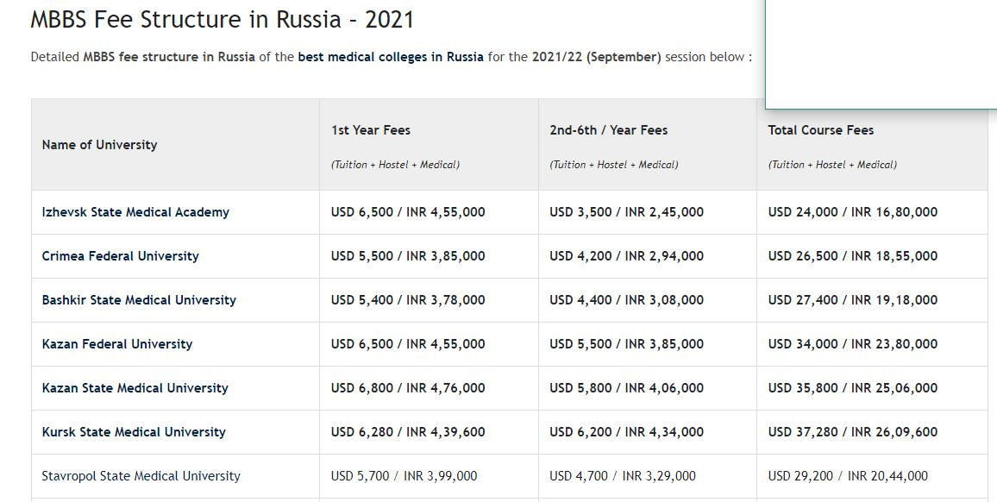

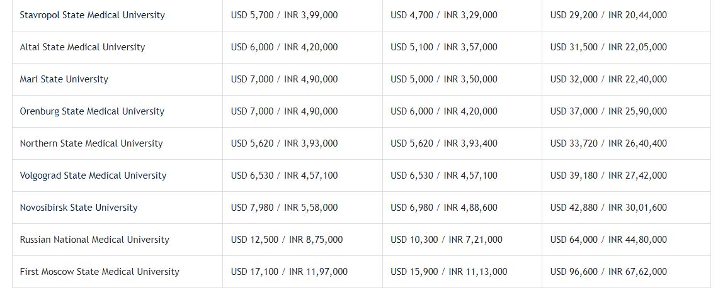

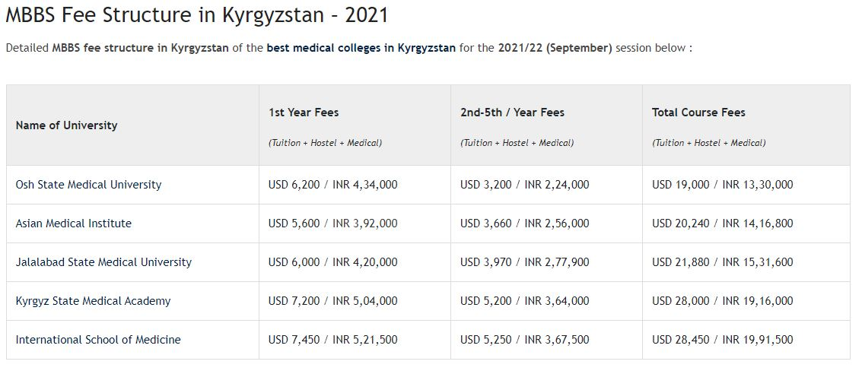

*Yearly MBBS fee in Russia includes tuition fee, hostel fee & medical insurance too.
* 1 USD = INR 70 applied at the time of preparing above MBBS fees structure.
* Amount payable may differ at the time of exchange depending on forex rate.

==========================================================================================================================

Is MBBS from Russia valid/recognized in India ?
Yes, the MBBS degree from Russia is fully valid & recognized in India. All medical universities in the above list have recognition from WHO and MCI/NMC. The list of recognized/approved medical colleges in Russia for Indian students is available on the official web links of NMC(Earlier known MCI) & WHO.
The university awards MD (Physician) degree to Indian students after they complete medical education successfully. This MBBS/MD (Physician)degree from Russia is valid & recognized in India. It is just an other name of what we call MBBS degree in India. Thousands of Indian students in the past who completed their MBBS from Russia are successfully working in India & many other countries after clearing the MCI Screening test/FMGE/Next Exam.

What is the eligibility for MBBS admission in Russia ?
The eligibility for MBBS admission in Russia for Indian students is easy & straight forward as below :
50% marks in PCB in 12th/Inter (40% marks for SC/ST/OBC)
NEET qualification (2019/2020/2021)
Minimum 17 years age (Till 31st December 2021)

* Few renowned medical universities in Russia require 60%-70% in 12th/Intermediate from Indian students instead of the 50% marks criteria set by MCI/NMC.

How to apply for MBBS in Russia ?
Indian students can apply for MBBS in Russia in 2021 through steps outlined below :
Student should submit 10th & 12th marksheet, NEET result & application forms.
The university will issue the admission letter within 2-3 working days.
Student should submit all original documents along with marksheets, passport, photos & medical reports.
The university will provide invitation letter in soft copy for study visa from it’s embassy in India.
We will compile & submit all documents together for study visa & collect it from embassy, when ready.
We will inform the student about group departure date from India to Russia.
Student must reach reach 2 days prior to departure date and collect all original documents and visa from our office.

* The above admission procedure to apply for MBBS in Russia is simple and can be done online or by visiting any of our offices.

What are the benefits of studying MBBS in Russia ?
Some of the most important benefits of studying MBBS in Russia are as follows :
No donation or entrance for Indian students as MBBS admission in Russia is done directly.
Admissions are granted solely on the basis of eligibility which is 50% marks & NEET qualification.
The total duration of MBBS in Russia is 6 years which ensures adequate clinical exposure & learning.
MBBS fees in Russia is very low i.e. between 16 Lac to 30 Lac for whole course including accommodation.
Full course of medical education is in English medium, especially for Indian students.
All medical colleges in Russia are recognized by WHO & MCI/NMC & hence degree is valid worldwide.
Classes do not have more than 15 students for better understanding & learning.
Separate hostel for Indian students which has round the clock security.
All basic amenities available in hostels and are free of cost for all foreign students.
Different types of accommodation options available like 2/3/4 seater rooms

Above all, Russia is the country which witnesses most number of admissions every year from India.

What is the medium of instruction of MBBS in Russia ?
The medium of instruction of MBBS in Russia is English language for Indian students.
The entire course of medical education is in English except the part where students interact with local patients.
However, students also learn the local language i.e. Russian (As a subject with regular tests of it too).
This in turn helps Indian students to communicate with local patients when they visit hospitals for their clinical classes.
This additional language makes it easier for them to communicate with local people and get to know the country better

What are the hostel facilities for Indian students in Russia ?
A brief overview of hostel facilities for Indian students in Russia are :
Indian students stay in the government hostels provided by university during their full tenure of MBBS in Russia.
Apart from that, the students can also choose to rent a flat/apartment in city and live by themselves from 2ndyear.
The hostels for Indian students in Russia are much superior and better than those provided in India.
This is one of the reasons that their parents back in India are sure that their wards are at a very safe destination.
Indian mess is available in Russian universities as huge number of Indian students are currently studying in them.
Indian mess is compulsory for students in 1st year in few selected medical universities of Russian Federation.
From 2nd year onwards, students can either prepare food themselves in hostel kitchens or continue to have food from Indian mess.
All facilities like electricity, hot & cold water, laundry, heating system in rooms, etc. are free for students by government/university.

What is the average cost of living in Russia ?
The average cost of living in Russia for Indian students is very less than other neighboring countries.
Indian students can easily spend a month in USD 80-100 including food, little travelling within city & some misc. expenses.
However, average cost of living in Russia entirely depends on the student’s lifestyle & his/her personal capacity.
The national currency of Russia is Rubles & at present stands at : 1 INR = 1 Ruble approximately

How do Indian students pay MBBS fees in Russia ?
Indian students can pay MBBS fees in Russia through 2 common methods. First, direct payment of full university fees after arrival in Russia which is most common method among Indian students. Second, transfer of fees directly to university’s bank account in Russia from any Indian bank. If the student wishes to transfer fees to a Russian medical college through bank, then this must be completed well before departure from India. In such case, the student must carry the fees transfer slip provided by bank along with himself/herself to show at university.
However, only selected universities have the facility to accept direct fees transfer from India in university’s official bank account. Hence, most of Indian students pay MBBS fees directly in Russia after their arrival.
How are MBBS classes conducted in Russia for Indian students ?
The MBBS classes in Russia for Indian students are planned and conducted in a very efficient way to offer best of both theoretical &practical knowledge :
MBBS classes in Russia for Indians never have more than 12-15 students.
This makes it really easy and comfortable for Indian students to directly interact with their teachers.
The teachers and professors who teach Indian students are highly skilled doctors, professors & Ph.D holders.
They have very high proficiency & experience to teach international students in English medium.
The first 2 years of MBBS classes in Russia are more inclined towards learning theoretical subjects of medicine.
During the 3rd year, students devote equal time to theoretical and practical classes with regular hospitals visits too.
Students acquire most clinical/practical skills from 3rd to 6th year, when they interact with local patients in government hospitals.

Will MBBS classes in Russia be online/offline for Indian students in 2021 ?
This is a completely 50/50 situation. The MBBS classes in Russia can be online as well as offline in 2021. As we are all well aware of the on going situation in whole world due to the Covid-19 pandemic, nothing is certain as of now. However, the option to conduct MBBS classes online in Russia can not be completely ruled out. Especially if the Covid-19 situation only gets worse by the end of 2021.

But this is one thing students should not worry about. Because even if the classes will be online then it’s beneficial for the students only. Firstly, they will be able to save their monthly living costs & flight expense of 1st year. Secondly, their education will not face any disturbances as they will be able to attend all classes from India online.
All Indian students who took MBBS admission in Russia in 2020 attended their classes online smoothly. It was in the mid of their 2nd semester when flights became operational & they departed to Russia. This was possible due to the addition of some more countries (Which included Russia & some others too) in “Air Bubble Agreement” that Indian government updated recently on mutual consent.

Is the decision to study MBBS abroad in Russia correct ?
Your decision to study MBBS in Russia can prove to be your best decision for pursuing MBBS from abroad.
It’s best for you if you qualify NEET but fail to secure a seat India due to the high cost of private colleges in India.
It is a great opportunity to get direct MBBS admission in Russia without any entrance exam.
There are a very fixed number of seats in Russian medical colleges for Indian students.
Hence, Indian students who really want pursue MBBS in Russia must plan in advance, if they want confirmed admission.
Admissions to study MBBS in Russia take place solely on the basis of eligibility criteria of university and MCI/NMC.
Above that, seats are allotted on a first come first serve basis without any sort of donation being involved.
These top medical colleges of Russia rank much higher than most renowned medical colleges in India.

Why should Indian students choose to study MBBS in Russia ?
The 2021 (September session) is one great opportunity for all Indian students to study MBBS in Russia.
Firstly, the ranking of some of the top medical universities in Russia is much better than top medical colleges of India.
Secondly, the total MBBS fees of Russia starts from just as low as 16 Lacs including the hostel accommodation &medical insurance too.
The duration of MBBS course in Russia is 6 years. This ensures that students acquire all necessary clinical skills and master them too.
Due to 6 years medical course, Indian students in Russia devote more time in hospitals as compared to those in Kyrgyzstan & Kazakhstan.
Next on, the total number of Indian students who choose to study MBBS in Russia every year is greater than any other country.
Last but the most important, the international flights to Russia are operational under the “Air Bubble Agreement”.
Hence, students from India will most probably travel to their destination cities in Russia just like last year

How is medical degree from Russia beneficial for Indian students ?
There are numerous factors that make MBBS from Russia very useful & beneficial apart from top class universities & superior hostels provided. Few of such facts that justify the above statement are :
Option for Indian students to practice there itself after completion of MBBS course in Russia.
Students can appear in MCI/MCI Screening Test/FMGE/NeXT in India to work as doctors permanently.
Indian students can also appear in USMLE, PLAB, NZREX, etc. to pursue PG in any of these countries.
Student exchange programs & summer internships are offered by all government medical universities of Russia.
Regular extra-curricular activities conducted by medical colleges for overall personality development of students.

Why to take MBBS admission in Russia through us ?
Concisely, the most important benefits that you get when you take MBBS admission in Russia through us are :
You can be 100% sure that you get what you pay for and at exactly the price shown on website.
No hidden payments for anything else except what is mentioned in the fees structure on website.
You can be sure that you will also get a confirmed seat provided you are eligible & have a strong desire to be a doctor.
All main pre-departure services in India & post-arrival services in Russia will be managed by us.
Students can contact us during their entire tenure of medical education for any valid assistance.

* Students who are interested to apply in the best medical universities of Russia can book their seats now as admissions are open.* This procedure can be done online (Recommended due to the ongoing Covid-19 pandemic situation) or by visiting any of our offices

About Medical Education in Russia
MBBS in Russia is one of the best choices one can make while choosing to pursue his/her career in studying MBBS abroad. Some useful facts that might make MBBS admission in Russia more relevant are :

The medical universities receive immense support and funding from government in order to maintain highest standards of education.
MBBS course from Russia has recognition from WHO & MCI/NMC which makes the MBBS degree valid globally.
Therefore, Indian students who graduate from these Russian medical universities can practice medicine anywhere in whole world.
The national language of Russia is Russian language & all foreign/Indian students attend it’s compulsory classes.
However, most of the Russians speak Russian language and many people also speak English language.
Indian students in Russia get the opportunity to participate in various exchange programs conducted by medical universities.
Under these programs, they can travel to other countries of Europe and learn about new advancements in field of medicine.

About Russia
Now that you are quite aware with the important points about MBBS in Russia, lets know a little about the country in brief. It was formerly known as USSR until 1991. It is the largest country in the world & has a coastline of more than 35,000 kms. running along the Pacific & Arctic oceans. Russia is such a vast country that it alone has 11 different times zones. Russia’s lakes contain approx. 1/4th of whole world’s liquid fresh water. The largest Russia’s water body is Lake Baikal, which is the world’s oldest, deepest, & purest fresh water lake. This lake alone contains more than 1/5th of world’s fresh surface water. The country’s soil is a very rich source of natural resources like natural gas, petroleum, coal, minerals, ores & timber.
Moscow (Moskva in Russian) is the capital city of Russia. Some other major cities are St. Petersburg, Kazan, Novosibirsk & Ekaterinburg. The climate of Russia has 2 major seasons i.e. summers & winters. Average temperature in summers ranges from 25 to 35 degrees while it is between 5 to -15 degrees during winters. However, the winters can sometimes be extreme and temperature can dip down to -30 degrees Celsius in central & western parts of Russia. The eastern parts of Russia i.e. the Siberian region witnesses a temperature of up to -75 during winters every year.

MBBS Abroad Links (Useful Websites)
Some of the MBBS abroad links (Especially useful for Indian students) are given below for
each country:-
About India :
NMC (National Medical Commission) : https://www.nmc.org.in/
WDOMS (World Directory of Medical Schools) : https://www.wdoms.org/
Education Loan (Indian Government) : https://www.vidyalakshmi.co.in/Students/
Scholarships (Indian Government) : https://scholarships.gov.in/

About Russia :
Ministry of Higher Education & Science of Russian Federation : https://minobrnauki.gov.ru/
Ministry of Health of Russian Federation : https://www.rosminzdrav.ru/en
Embassy of India, Moscow, Russia : https://indianembassy-moscow.gov.in/index.php

About Ukraine :
Ministry of Health of Ukraine : http://en.moz.gov.ua/
Ministry of Education & Science of Ukraine : https://mon.gov.ua/ua
Embassy of India, Kiev, Ukraine : http://www.eoiukraine.gov.in/index.php

About Kyrgyzstan :
Ministry of Health of Kyrgyz Republic : http://www.med.kg/ru/
Ministry of Education & Science of Kyrgyz Republic : http://edu.gov.kg/kg/
Embassy of India, Bishkek, Kyrgyzstan : https://indembbishkek.gov.in/

About Kazakhstan :
Ministry of Health of Kyrgyz Republic : http://dsm.gov.kz/en
Ministry of Education & Science of Kyrgyz Republic : http://www.edu.gov.kz/kz/
Embassy of India, Bishkek, Kyrgyzstan : http://www.indembastana.gov.in/

